**Java String compare :**

We can compare String in Java on the basis of content and reference.

It is used in authentication (by equals() method), sorting (by compareTo() method), reference matching (by == operator) etc.

There are three ways to compare String in Java:

By Using equals() Method

By Using == Operator

By compareTo() Method

**By Using equals() Method:**

The String class equals() method compares the original content of the string. It compares values of string for equality. String class provides the following two methods:

public boolean equals(Object another) compares this string to the specified object.

public boolean equalsIgnoreCase(String another) compares this string to another string, ignoring case.

**By Using == operator:**

**By Using compareTo() method**

The String class compareTo() method compares values lexicographically and returns an integer value that describes if first string is less than, equal to or greater than second string.

Suppose s1 and s2 are two String objects. If:

s1 == s2 : The method returns 0.

s1 > s2 : The method returns a positive value.

s1 < s2 : The method returns a negative value.

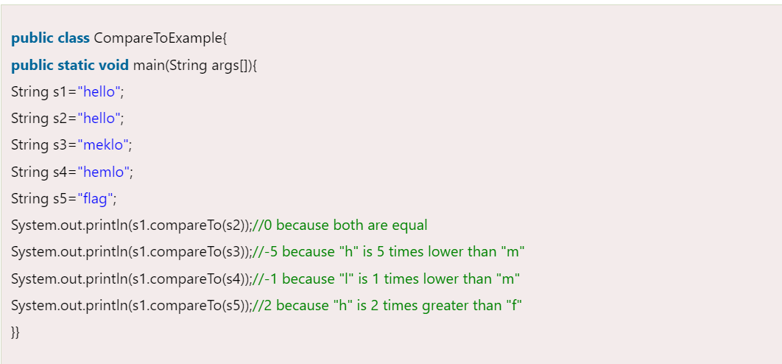

**Java String compareTo(): empty string:**

